**Choosing your courses**

**The first thing to do, if you haven’t already, is make sure you sign up to the** [**UCAS Hub**](https://www.ucas.com/account/login?returnUrl=/dashboard%23%2F).

Your[**UCAS Hub**](https://www.ucas.com/account/login?returnUrl=/dashboard%23%2F) will give you all the tools and information you need – in one place. We can then guide you to the information you need. You can easily explore, filter, and favourite the things which matter to you most. The best bit is that you’ll have your own dashboard, which you can customise and tailor to suit you, and you can organise the tools that help you most, remove the ones you don’t need, make notes, and tick off things on your to-do list.

|  |
| --- |
| **How do I sign up?**  The UCAS Hub is free and easy to use. All you need to do is follow these three simple steps to sign up:  **Step 1 – Register**  To get started, visit [ucas.com/hub](https://www.ucas.com/hub).  **Step 2 – Verify your account**  Once you’ve registered, you’ll be asked to verify your account. An email will be sent to the email address you registered with and all you need to do is hit ‘**Activate account**’.  **Step 3 – Sign in**  Now you’re ready to sign in and start exploring! The first time you do, we’ll ask you some extra questions so we can help you find the right info.  At any time to pick up where you left off, visit [ucas.com/hub](https://www.ucas.com/hub) or click ‘**Sign in’** on the top right-hand side of any page on ucas.com and select ‘**Students**’. |

**Activity 1: What you have learnt so far?**

Using all the research you have done so far, write down answers to the questions below so you can focus your next stage of research onto specific courses and universities you might apply to.

|  |  |
| --- | --- |
| What are your favourite subjects? Where you get your best marks or are there new ones you have found that really appeal? |  |
| Are you more interested in studying an academic subject (such as maths, history, French, chemistry) or something that has a more vocational link (such as retail, software design, or engineering)? |  |
| If you have a career you’re really interested in, do you need particular degree subjects or qualifications? |  |
| Are you interested in doing a work-based placement as part of your degree course – it makes your course longer (4 years) but means you can get experience in a career area related to the subject you’re studying. |  |
| Do you have preferences for the location or sort of university or college you want to attend? |  |

**Activity 2: Broaden your horizons**

There are over 35,000 courses you can choose from, so have a go at these tasks to try to help find the perfect courses for you.

Sign in to your [**UCAS Hub**](https://www.ucas.com/account/login?returnUrl=/dashboard%23%2F) and search for:

1. three courses that link directly to your favourite subject.
2. three different courses that are related to each of the subjects you are currently studying.

Remember to use the favourite tool on the Hub to shortlist any you are interested in. Once you have done this, draw up a list of your top 5 subjects – you can also do this in the Hub by favouriting them to your ‘Top Five Courses’.

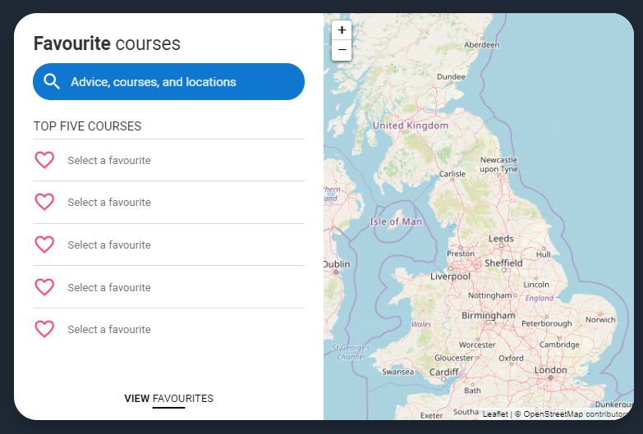

|  |
| --- |
| **Subjects/courses I’m interested in:** |
|  |
|  |
|  |
|  |
| 5. |

**Activity 3: Choosing the right course**

We all have different ways of learning, which influence course choices, and ultimately, success on a course. You should think carefully about each of the courses that you are interested in to make sure it’s right for you.

Using the following resources, complete the table below with as much information as possible, and tick off each one once you have done it.

1. [**Virtual open days**](https://www.ucas.com/ucas/events/find/scheme/virtual-and-digital/type/open-day) **and** [**virtual tours**](https://www.ucas.com/undergraduate/what-and-where-study/open-days-and-events/virtual-tours)**:** sign up to a virtual open day or take a virtual tour for each of your universities/courses? €
2. [**UCAS search tool**](https://digital.ucas.com/search)**:** if you have favourited your courses on your Hub then make sure you click through to read about the course in more detail, it will give you a course summary, entry requirements, fees and funding and more. €
3. **University and college websites:** make sure you go to each specific university or college’s website to read more about the course you might apply to.€
4. **Will there be opportunities to visit in person?** Find out if there will be open days run later in the year too. If you can’t find this out, get in touch with the university or college directly. €

|  |  |  |  |  |  |
| --- | --- | --- | --- | --- | --- |
| **What you need to find out** | **Subject/course 1** | **Subject/course 2** | **Subject/course 3** | **Subject/course 4** | **Subject/course 5** |
| 1. **Entry requirements:** do they match my subjects/grades?   *If you have predicted grades, consider applying for at least one course with lower entry requirements to have as a reserve offer.* |  |  |  |  |  |
| 1. **Does the course match my interests** – what module choices and content does it offer? Do they relate to my career plans? Am I happy with both the core and optional modules? Consider all years of the course. |  |  |  |  |  |
| 1. **Teaching and assessment –** How is the course taught? What is the split between formal teaching and independent study? How much time will I spend in lectures or seminars?How is the course assessed – exams or coursework? |  |  |  |  |  |
| 1. **Costs** – what are the tuition fees and likely living expenses? Are there any scholarships or bursaries on offer? |  |  |  |  |  |
| 1. **Work experience:** does the course or university offer any internship or placement opportunities? What have other graduates gone on to do? Are there links to employers and support for career development? |  |  |  |  |  |

|  |  |  |  |  |  |
| --- | --- | --- | --- | --- | --- |
| 1. **Professional accreditation:** is the course recognised by appropriate professional bodies? |  |  |  |  |  |
| 1. **What are three pros and cons** of this subject/course? |  |  |  |  |  |
| 1. **Reflection**: What is the real likelihood of me applying to this course.   (Rank 1 – 10, with 10 being most likely) |  |  |  |  |  |